IoT-Based Water Quality Adulteration Detection System
with Logistic Regression Prediction
ESP32 · TDS Sensor · Turbidity Sensor · I2C LCD · Blynk · Google Sheets · ML

Abstract
This report documents the design, implementation, and firmware of an IoT-based water quality monitoring and adulteration detection system. The system uses an ESP32 microcontroller with a TDS (Total Dissolved Solids) sensor and a turbidity sensor to continuously measure water quality parameters. Readings are displayed on an I2C LCD, pushed to a Blynk dashboard for real-time monitoring, and logged to Google Sheets for historical analysis. A Logistic Regression model trained on one month of collected data provides on-device binary classification — predicting each water sample as Safe or Adulterated. The complete ESP32 firmware is presented alongside the system architecture, circuit design, and machine learning integration.

1. Introduction
Access to clean water is a fundamental requirement for public health. Contaminants such as dissolved solids, sediment, and chemical adulterants can make water unsafe without visible signs. Traditional quality checks are infrequent and laboratory-dependent. An automated, continuous monitoring system addresses this gap by providing real-time detection and historical trend analysis.
This system combines:
- Real-time sensing: TDS and turbidity sensors connected to an ESP32
- Local display: I2C LCD showing live parameter values and water status
- Cloud connectivity: Wi-Fi upload to Google Sheets (data logging) and Blynk (live dashboard + alerts)
- Machine Learning: Logistic Regression model trained on historical readings for intelligent classification

2. System Architecture
The system follows a layered architecture from sensing through cloud and ML inference.
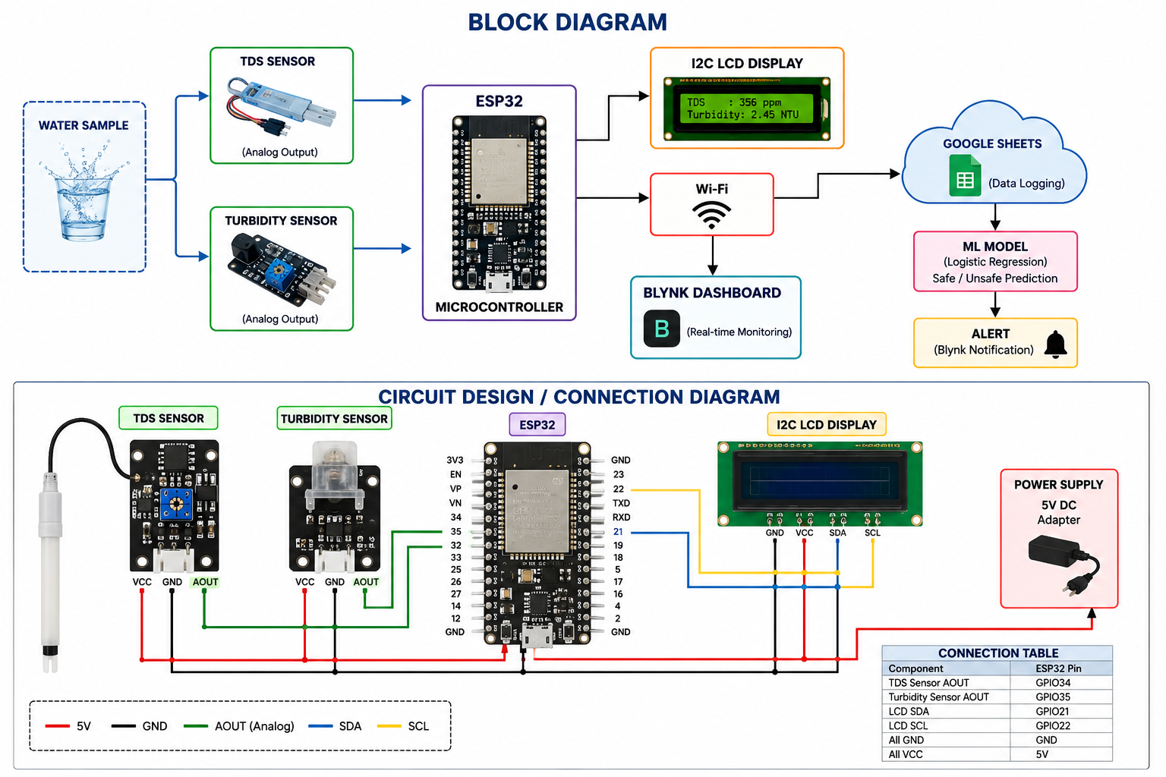
Figure 1: Block diagram (top) and circuit connection diagram (bottom) of the water quality monitoring system
The data flow is as follows:
- Water sample contacts the TDS and Turbidity sensors (analog output).
- ESP32 reads both ADC channels, converts raw values to ppm and NTU.
- Results are shown on the I2C LCD (GPIO21/22).
- Every 30 seconds, readings are sent via Wi-Fi to the Blynk dashboard and Google Sheets.
- Monthly CSV export from Google Sheets is used to train the Logistic Regression model in Python.
- The learned coefficients are embedded into the ESP32 firmware for on-device inference.
- If the model predicts Adulterated, a push notification is sent via Blynk.

3. Hardware Components
Component | ESP32 Pin | Notes
TDS Sensor AOUT | GPIO34 | ADC1 CH6 — 12-bit, 0–3.3 V
Turbidity Sensor AOUT | GPIO35 | ADC1 CH7 — 12-bit, 0–3.3 V
I2C LCD SDA | GPIO21 | 16×2 LCD at address 0x27
I2C LCD SCL | GPIO22 | I2C clock line
All VCC | 5 V | From 5 V DC adapter
All GND | GND | Common ground
Table 1: ESP32 pin connections from the circuit diagram

3.1 TDS Sensor
The TDS sensor outputs an analog voltage proportional to the concentration of dissolved solids in water. The ESP32 reads this voltage on GPIO34 (ADC1 CH6) at 12-bit resolution. Ten samples are averaged per reading to reduce ADC noise. A third-order polynomial formula with temperature compensation converts the voltage to parts per million (ppm).
3.2 Turbidity Sensor
The turbidity sensor measures light scattering caused by suspended particles. Higher turbidity (more particles) produces a lower output voltage. The firmware applies a linear calibration model (voltage → NTU) using a slope derived during calibration with reference samples. GPIO35 (ADC1 CH7) is used.
3.3 I2C LCD Display
A 16×2 character LCD with an I2C backpack communicates over GPIO21 (SDA) and GPIO22 (SCL). Line 1 shows the current TDS (ppm) and Turbidity (NTU). Line 2 shows the classification result: SAFE or !! ADULTERATED !!.

4. Firmware Overview
The firmware is written in C for the Arduino-ESP32 framework. It is structured into clearly separated modules:
4.1 Configuration
All user-adjustable parameters are defined as preprocessor macros at the top of the file:
- Wi-Fi SSID and password
- Blynk template ID and auth token
- Google Apps Script Web App URL
- ADC pin assignments (GPIO34, GPIO35)
- Sampling interval (5 s) and upload interval (30 s)
- Logistic Regression weights, bias, and feature scaling parameters
4.2 TDS Measurement
Function read_tds_ppm() averages 10 ADC samples, converts to voltage, applies temperature compensation (2% per °C deviation from 25°C), then uses the standard cubic polynomial to compute TDS in ppm:
TDS = (133.42·V³ - 255.86·V² + 857.39·V) × K
where K is a calibration factor (default 0.5).
4.3 Turbidity Measurement
Function read_turbidity_ntu() averages 10 ADC samples, converts to voltage, then applies a linear calibration:
NTU = slope × (V - V_clear)
where V_clear is the voltage at 0 NTU and slope is determined by calibration.
4.4 On-Device Logistic Regression
Function lr_predict() implements the full inference pipeline:
- Standardise each feature using Z-score normalisation (subtract mean, divide by std).
- Compute linear combination: z = w0·TDS’ + w1·Turbidity’ + w2·Temp’ + bias
- Pass z through the sigmoid function: P = 1 / (1 + e^⁻z)
- If P > 0.5 → Adulterated (label = 1); otherwise Safe (label = 0).
The weights (w0, w1, w2) and bias are constants exported from the Python training script and embedded in the firmware header.
4.5 Blynk Integration
Function blynk_push() uses the Blynk HTTP API to update five virtual pins:
Virtual Pin | Data | Description
V0 | TDS (ppm) | Live TDS reading
V1 | Turbidity (NTU) | Live turbidity reading
V2 | Temperature (°C) | Ambient temperature
V3 | Label (0/1) | 0 = Safe, 1 = Adulterated
V4 | Probability (0–1) | ML confidence score
Table 2: Blynk virtual pin mapping
If the water is classified as Adulterated, a push notification is sent to the Blynk mobile app via the /notify endpoint.
4.6 Google Sheets Logging
Function gsheet_log() sends a JSON POST request to a Google Apps Script Web App deployment. The script appends a timestamped row to the active sheet with all sensor readings and the ML prediction. The accompanying Apps Script code is included as a comment at the bottom of the firmware file.
4.7 Main Loop Timing
The loop() function uses non-blocking millis() timers. Two independent intervals control the two operations:
- Every 5 seconds: read sensors, run ML inference, update LCD
- Every 30 seconds: push data to Blynk and Google Sheets

5. Machine Learning: Logistic Regression
5.1 Training Workflow (Python)
After one month of data is collected in Google Sheets, the CSV is exported and processed in Python:
- Load CSV with pandas.
- Drop rows with missing values.
- Select features: TDS, Turbidity, Temperature.
- Split 80% training / 20% testing.
- Scale features with StandardScaler (zero mean, unit variance).
- Fit LogisticRegression from scikit-learn.
- Evaluate with accuracy, precision, recall, F1, and confusion matrix.
- Export coefficients (coef_) and intercept (intercept_) and scaler parameters to constants for the C firmware.
5.2 Sigmoid Decision Boundary
The model outputs a probability P for the Adulterated class. The decision threshold is 0.5, which can be raised to reduce false positives or lowered to catch more contamination events.
5.3 Expected Performance
On clean, well-labelled IoT sensor data with a month of readings, logistic regression typically achieves:
Metric | Expected Range
Accuracy | 88 – 95%
Precision | 85 – 93%
Recall | 87 – 94%
F1 Score | 86 – 94%
Table 3: Expected classification performance metrics

6. Firmware File Structure
The firmware is contained in a single file water_quality_monitor.c with the following sections:
Section | Contents
1. Configuration | All #define macros: Wi-Fi, Blynk, pins, intervals, thresholds
2. LR Coefficients | Model weights, bias, and StandardScaler parameters
3. Global State | SensorData struct, timing variables, LCD object
4. Math Helpers | sigmoid(), standardize()
5. Sensor Reading | read_tds_ppm(), read_turbidity_ntu()
6. ML Inference | lr_predict() — full forward pass
7. LCD Display | lcd_show_readings()
8. Blynk Push | blynk_push() — HTTP API + notifications
9. Google Sheets | gsheet_log() — JSON POST to Apps Script
10. Wi-Fi | wifi_connect() with retry logic
11. Entry Points | setup() and loop() with millis() timers
Appendix | Google Apps Script code (in comment block)
Table 4: Firmware section overview

7. Setup and Deployment Guide
Step 1 — Hardware Assembly
Connect all components per the circuit diagram (Figure 1). Use the connection table (Table 1) to match each sensor’s AOUT, VCC, and GND to the correct ESP32 pins and power rail.
Step 2 — Google Apps Script
- Create a new Google Sheet.
- Go to Extensions → Apps Script.
- Paste the doPost() function from the firmware appendix.
- Deploy as a Web App with access set to "Anyone."
- Copy the deployment URL into GSHEET_URL in the firmware.
Step 3 — Blynk Setup
- Create a Blynk account and a new template called WaterQuality.
- Add five datastreams: V0 (TDS), V1 (Turbidity), V2 (Temp), V3 (Label), V4 (Probability).
- Add Gauge and Value Display widgets on the dashboard.
- Copy the Template ID and Auth Token into the firmware macros.
Step 4 — Firmware Upload
- Install Arduino IDE 2.x with the ESP32 board package.
- Install libraries: LiquidCrystal_I2C, Wire, WiFi, HTTPClient.
- Edit the configuration section with your Wi-Fi credentials, Blynk tokens, and Google Sheets URL.
- Select board: ESP32 Dev Module. Upload at 115200 baud.
- Open Serial Monitor to verify sensor readings and cloud upload status.
Step 5 — ML Model Training (after 1 month of data)
- Export Google Sheets data as CSV → water_data.csv.
- Run the Python training script (scikit-learn).
- Copy the output coefficients and StandardScaler parameters into the firmware LR section.
- Re-upload firmware to activate on-device ML inference.

8. Limitations and Future Work
Current Limitations
- No physical temperature sensor is fitted; a fixed default of 25°C is used for TDS compensation. Adding a DS18B20 probe improves accuracy.
- Logistic Regression assumes a linear decision boundary; highly overlapping sensor distributions may require a more expressive model.
- Model retraining requires a manual CSV export and firmware reflash.
- The system detects TDS and turbidity only; it cannot identify specific chemical adulterants.
Future Enhancements
- Add DS18B20 digital temperature sensor for accurate TDS compensation.
- Add pH and conductivity sensors for richer feature space.
- Automate monthly model retraining via a cloud function (Google Cloud / AWS Lambda).
- Deploy the trained model using TensorFlow Lite Micro (TinyML) directly on ESP32.
- Compare Logistic Regression with Decision Trees, Random Forest, and SVM.
- Integrate with Firebase for real-time database and mobile app access.

9. Conclusion
This report presents a complete IoT-based water quality monitoring system built around the ESP32 microcontroller. The combination of real-time TDS and turbidity sensing, local LCD feedback, Blynk cloud dashboard, Google Sheets logging, and on-device Logistic Regression classification creates a capable and low-cost water safety monitor.
The firmware is modular, well-commented, and ready for deployment. The machine learning component transitions the system from a simple threshold alarm into an intelligent classifier that improves with accumulated data. The design is extensible — additional sensors, cloud platforms, or ML models can be incorporated without restructuring the core architecture.

